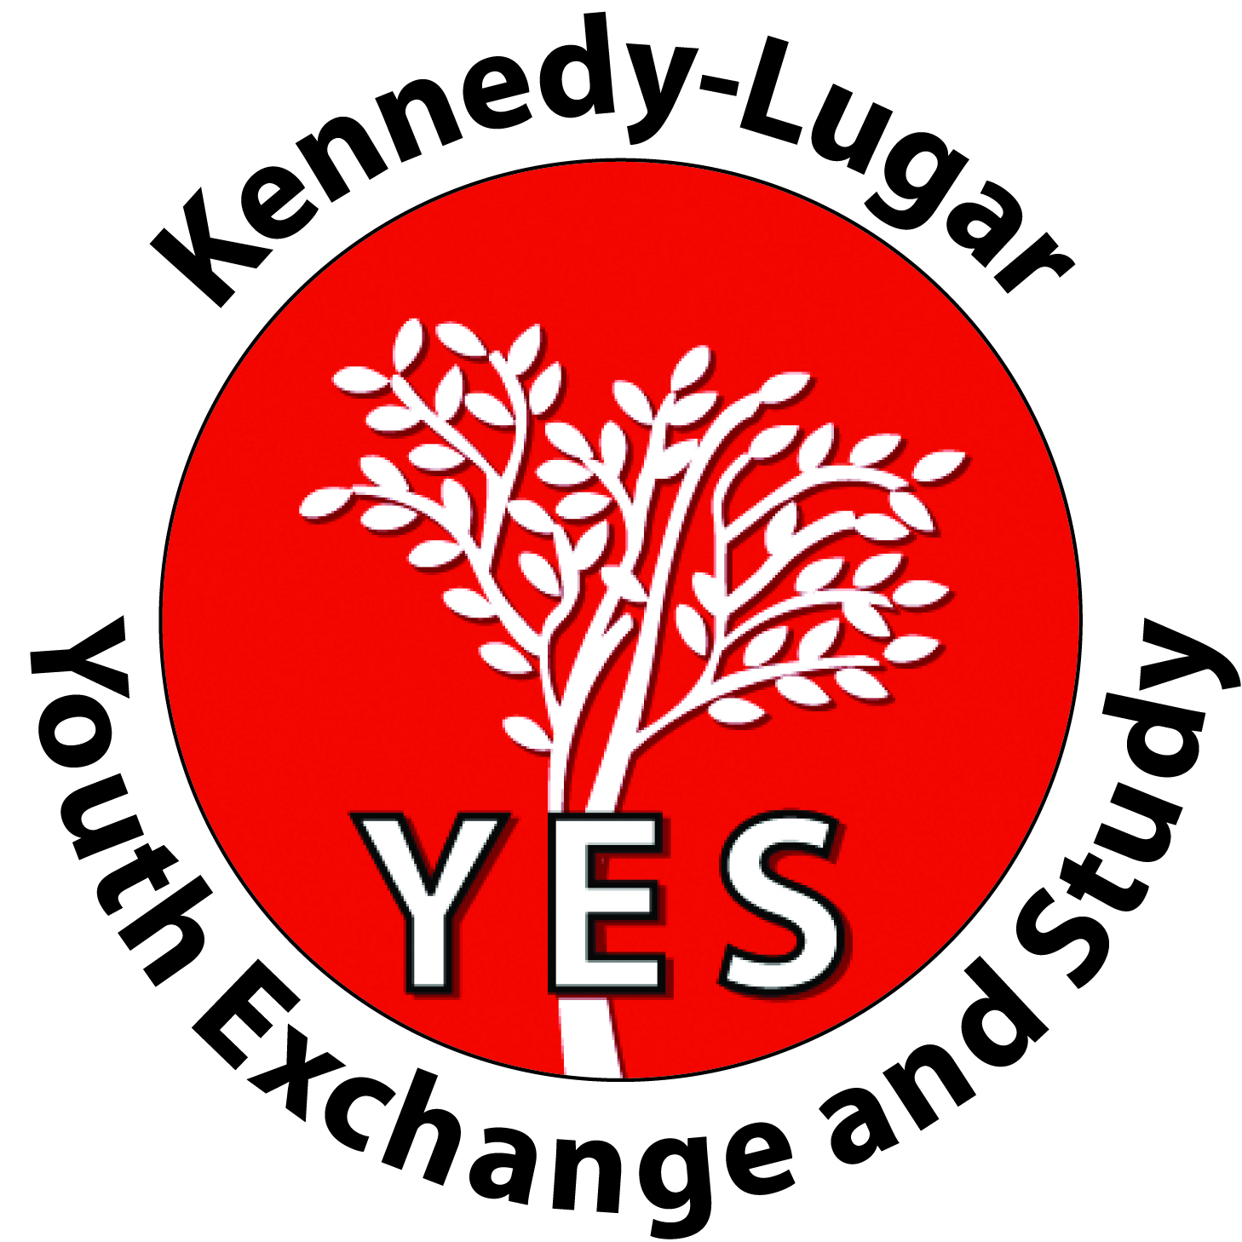
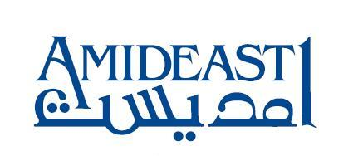
SHARE OMAN WITH AN AMERICAN STUDENT!
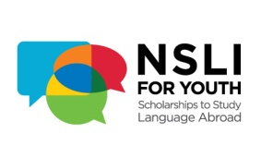
- Are you looking to experience American culture?
- Are you an Arabic Speaking family and have a good command of English?
- Do you live in the Muscat area between Al Qurm and Al Mawaleh?
- Would you like to share Omani culture and holidays with an American student?

If you’ve answered yes to all of the above, then hosting an American student could be for you.

These programs are funded by the US Embassy and are administered by AMIDEAST with assistance from the Ministry of Education. The students are between the ages of 15 and 18 and are medically insured and attend bi-lingual private schools or institutes in the Muscat area.
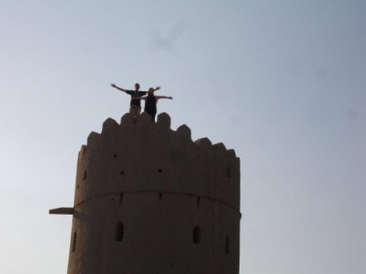
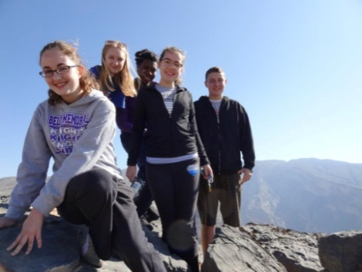
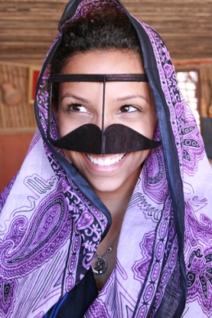
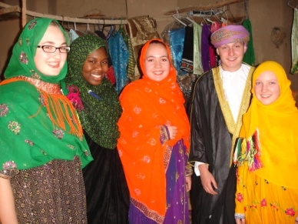
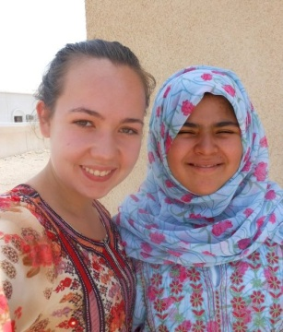
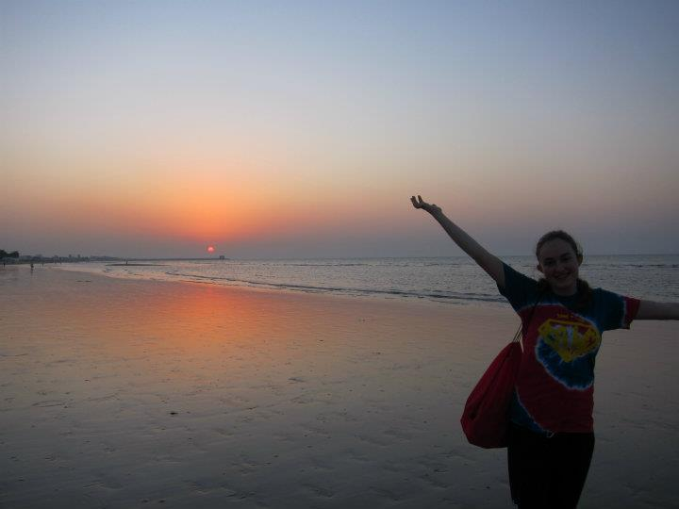
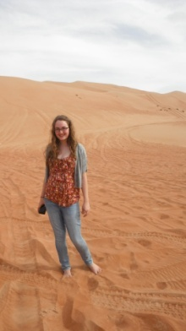
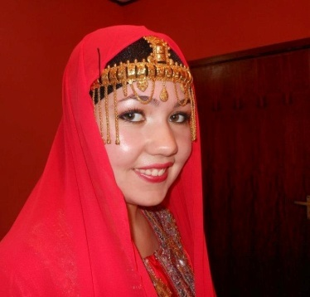
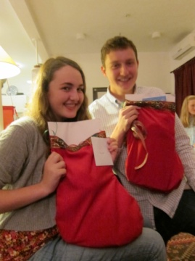
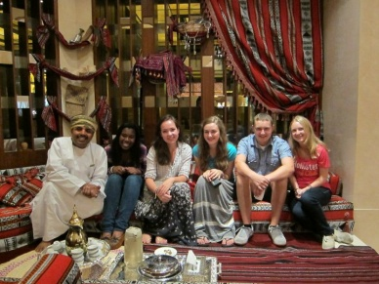
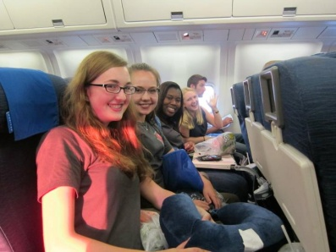
If you are interested in hosting short term (3 weeks this summer) or long term (1 academic year starting in September) programs please contact Fatin Al Maawali, Program Manager for Exchanges on 2459-0309 or by email on falmaawali@amideast.org

