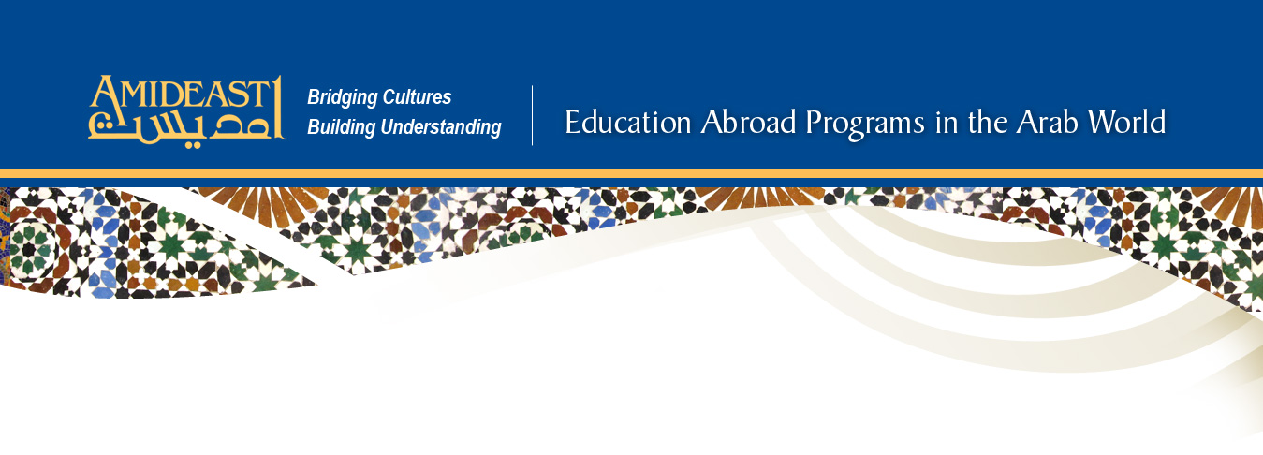
Customized Program Information Form

Note: When completing this form, please provide as much information as possible, feel free to attach an extra page with more detail if the space provided is insufficient. After discussion by phone, this form will be used when drafting a program proposal and budget as well as to assess the feasibility of implementing this project.

BASIC INFORMATION

Sponsoring Institution/Organization:

Principal Contact Person:

Phone: Mobile: Email:

PROGRAM LOGISTICS

Proposed Program Dates: Are these dates flexible? Yes No

Proposed Local Institution/ Partner (if any):

Group Size (please indicate range):
(Students) (Faculty) (Other)

Group Dynamics (please indicate range):
(Age) (Gender Ratio)

Students’ Language Level:
(Arabic) (French: Morocco and Tunisia only)

Source of Funding: Student Parent Institutional Government Grant

Estimated Total Program Cost: None Not applicable
(Amount)

Housing Preference: Students per room/ placement:

Per Student Cost for Housing and Meals: None Not applicable

(Amount)

PROGRAM COMPONENTS

Please describe the proposed program focus, goals and objectives:

Describe any specific places that you would like the group to visit:

All programs include an arrival orientation and a farewell dinner or similar gathering. Please indicate which of the following other elements you wish the program to include:

Pre-departure Orientation: Yes No Local Transportation: Yes No

Colloquial Arabic Courses (if not part of core program): Yes No

Field Trips in Host City: Yes No
(Please describe – attach extra page if needed)

Excursions Outside Host City: Yes No
(Please describe – attach extra page if needed)
Lectures on Host Culture and Society:
(List specific topics desired – attach extra page if needed)

Service Learning Experiences: Yes No

Other Special Cultural Events:
(Please describe)

Request was completed by:

Phone: Email:

Additional Contacts:

Please mail this completed form to:
AMIDEAST Education Abroad Programs
1730 M St. NW, Suite 1100
Washington, DC, 20036-4505
Alternatively, you may email (edabroad@amideast.org) or fax (202-776-7029) this form to AMIDEAST.
Please contact us with any questions or concerns at 202-776-9629 or edabroad@amideast.org.

